Overview
The following API perform basic CRUD operation to three database tables, student, course and register tables.

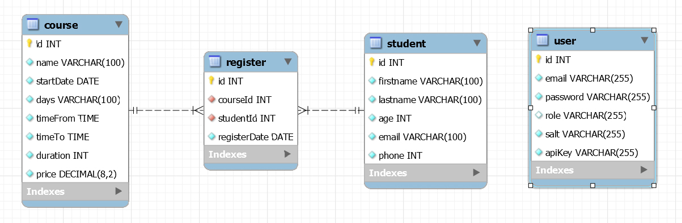

API URL format:
Base-endpoint/<api-key>/api/<endpoint>
Base-endpoint/<api-key>/api/<endpoint>/<student_id | course_id>
Base-endpoint/<api-key>/api/<endpoint>/<course_id>/<student_id>

The api url is made of 3 ot 4 parts:

- The Base endpoint
- API keys
- The Endpoint
- and 1 to 2 optional IDs

Base-endpoint:
The base endpoint is part: http://foxcodes.co/ice_malta/php/lesson_12/

API Key:
The API Key come after the Base endpoint. It always start with 'key_'

Ex: key_VBeiUvaq6UrUShwIr5MRK1FSe8eq+Zya+mogRt5OBI=

API Keys has two level of permission:

User level - can perform only 'GET' http request.
Admin level - can perform 'GET', 'POST', 'PUT' and 'DELETE' http request.

Endpoint:
The are 3 different Endpoint:
student - use to fetch, add, delete, and update student/s data to database.
course - use to fetch, add, delete, and update course/s data to database.
register - use to register or remove students to courses

Optional IDs:
IDs are used in 'GET', 'PUT' and 'DELETE' http request.
'POST' request doesn't require an ID, while 'GET' only need an ID when fetch data of a single course or student.

When using the register endpoint and performing a Delete request two ids are required.
A Student id ‘s_\d’ and a course id ‘c_\d’. (\d is to be replased with the course or student id).

Ex: ../register/c_1/s_2 or ../register/s_2/c_1

To remove all student form a course or remove all course from a student the ‘all’ keyword can be use.
Ex: ../register/c_all/s_2 or ../register/s_all/c1

____________________________________________________________________________________________________________

GET Examples:
Student Endpoint:
http://localhost/ice_malta/php/lesson_12/<endpoint>/api/student
http://localhost/ice_malta/php/lesson_12/<endpoint>/api/student/2

Course Endpoint
http://localhost/ice_malta/php/lesson_12/<endpoint>/api/course
http://localhost/ice_malta/php/lesson_12/<endpoint>/api/course/1

Register Endpoint
http://localhost/ice_malta/php/lesson_12/<endpoint>/api/register

POST Examples:
Student Endpoint:
http://localhost/ice_malta/php/lesson_12/<endpoint>/api/student
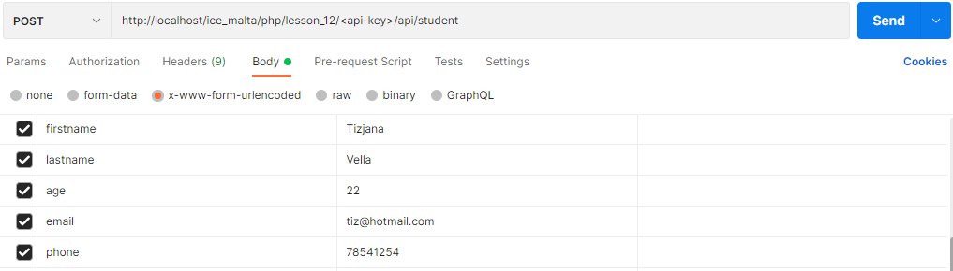
Course Endpoint
http://localhost/ice_malta/php/lesson_12/<api-key>/api/course

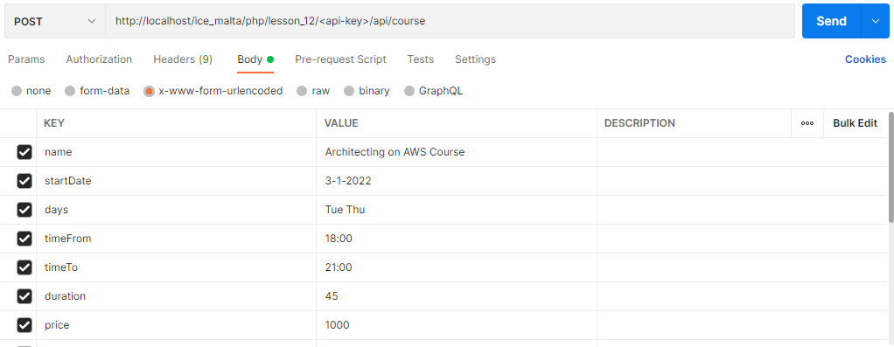
- startDate to be enterd as ‘DD-MM-YYYY ‘ or ‘D-M-YY’ or ‘D-M-YYYY’ format.
- days are to be enterd as 3 letter day, with space seperations as ’ Mon Tue Wed Thu Fri’
- timeTo and timeFrom are to be enterd as ‘HH:MM’ format

Register Endpoint
http://localhost/ice_malta/php/lesson_12/<api-key>/api/register

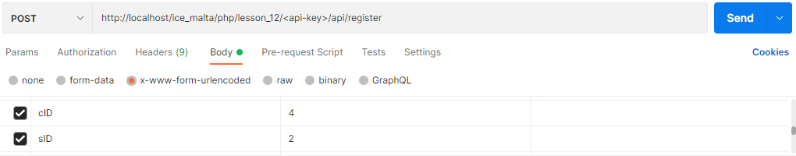
PUT Examples:

DELETE Examples:

